### 

**Install Cloudwatch Agent on Ec2 Linux Instance to get the Memory metrics on AWS Cloudwatch**

Standard Operating Procedure

Date: 23/07/2024

Author: Akalya

Introduction **3**

Purpose of the Document 3

Scope of the Document 3

**Procedure** 4

**References** **7**

# Introduction

## Purpose of the Document

This document is intended to provide step-by-step instructions for installing the CloudWatch Agent on an EC2 instance, configuring it to collect specific metrics and logs, and displaying these metrics in a CloudWatch dashboard.

## Scope of the Document

* Launching an EC2 instance with the appropriate IAM role.
* Configuring security groups.
* Installing and configuring the CloudWatch Agent.
* Collecting memory metrics and logs.
* Troubleshooting common issues.

# Procedure

## **a) Launch EC2 Instance with IAM Role**

* Log in to your AWS Management Console as the root user.
* 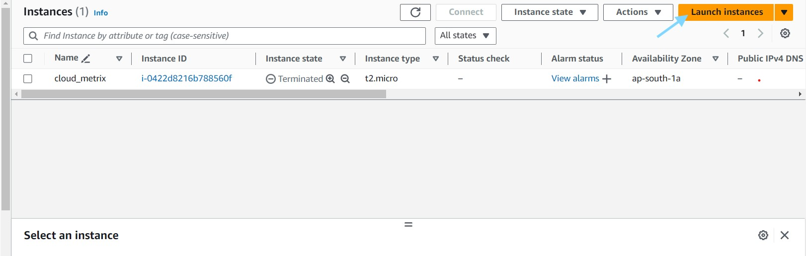Navigate to the EC2 dashboard and launch a new instance.
* Assign the IAM role cloud watch agent admin service to the instance.

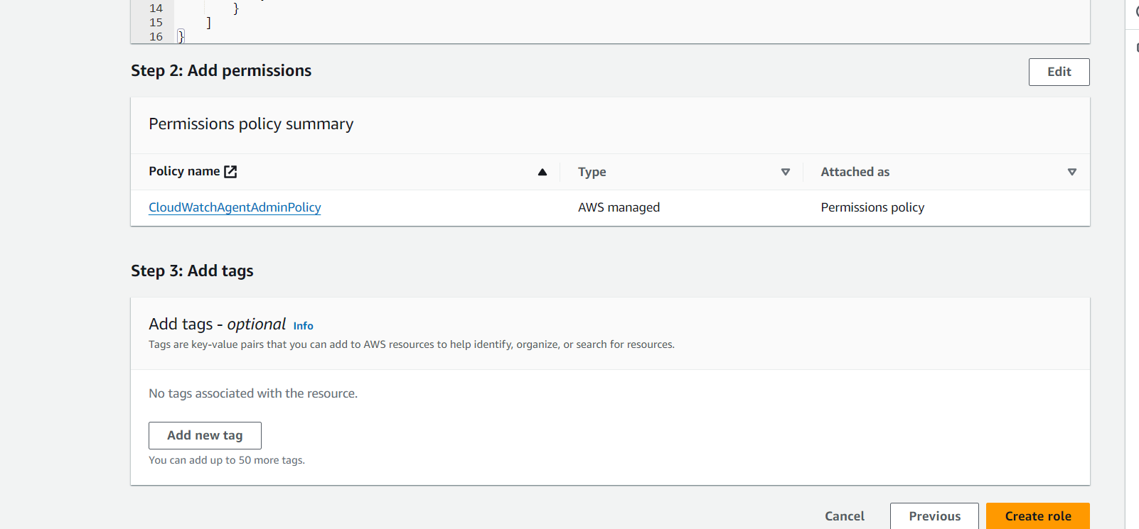

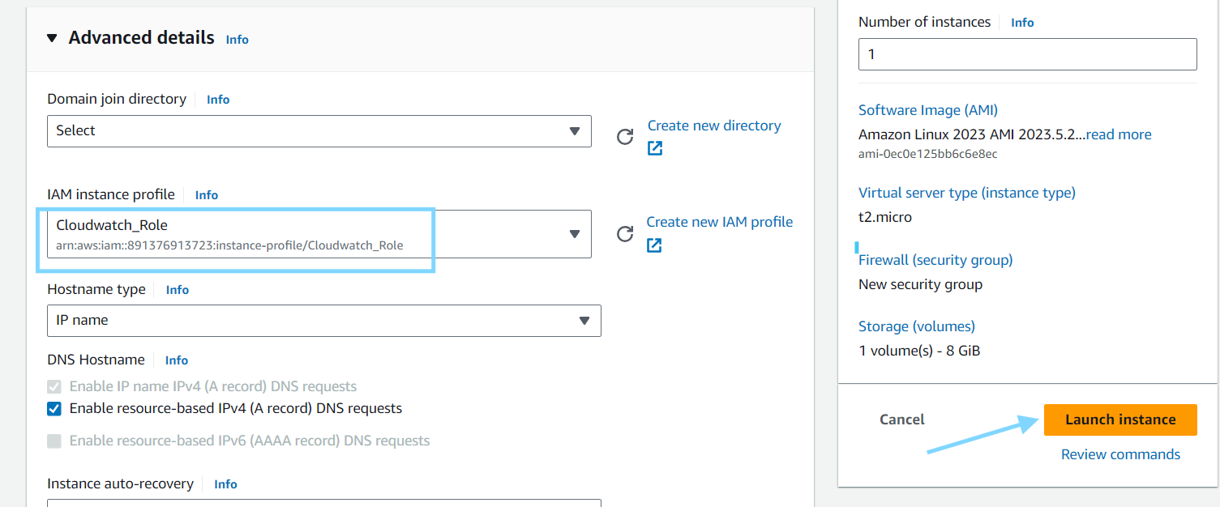

* Configure the security group to allow HTTP and SSH access:
  + HTTP: Port 80
  + SSH: Port 22

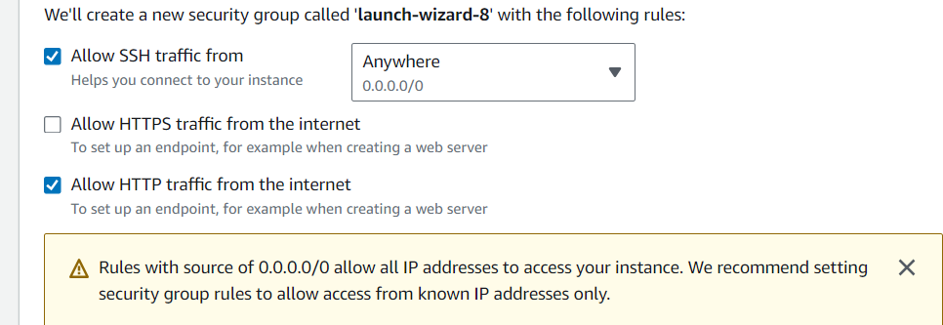

**b) Connect to the EC2 Instance**

* Use MobaXterm or any other SSH client to connect to the EC2 instance.

**c) Download and Install the CloudWatch Agent**

* Find the appropriate CloudWatch Agent download link for your OS from the [official documentation](https://docs.aws.amazon.com/AmazonCloudWatch/latest/monitoring/install-CloudWatch-Agent.html).
* Download the CloudWatch Agent:

***wgethttps://s3.amazonaws.com/amazoncloudwatch-agent/amazon_linux/amd64/latest/amazon-cloudwatch-agent.rpm***

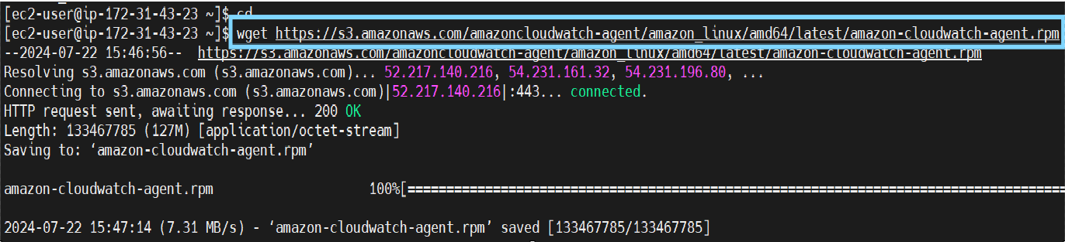

* Install the CloudWatch Agent:

***sudo rpm -U ./amazon-cloudwatch-agent.rpm***

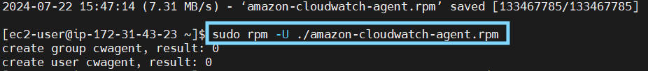

**d) Configure the CloudWatch Agent**

* Run the configuration wizard:

***sudo /opt/aws/amazon-cloudwatch-agent/bin/amazon-cloudwatch-agent-config-wizard***

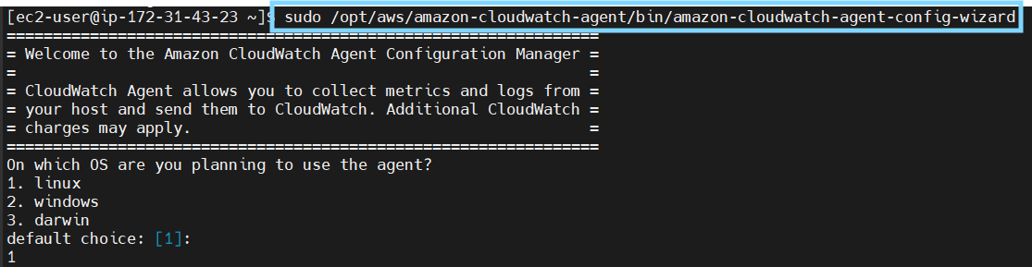

* Follow the prompts to configure the agent, specifying the instance type and the metrics you want to collect.

**e) Start the CloudWatch Agent**

* Start the agent using the configuration file:

***sudo /opt/aws/amazon-cloudwatch-agent/bin/amazon-cloudwatch-agent-ctl -a fetch-config -m ec2 -c file:/opt/aws/amazon-cloudwatch-agent/bin/config.json -s***

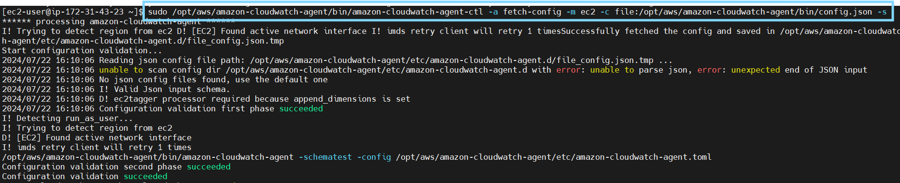

**f) Verify Metrics in CloudWatch**

* + - * Wait a few minutes for data to be collected.
      * Navigate to the CloudWatch section in the AWS Management Console.
      * Go to Metrics and look for the cwagent namespace to view the collected metrics.

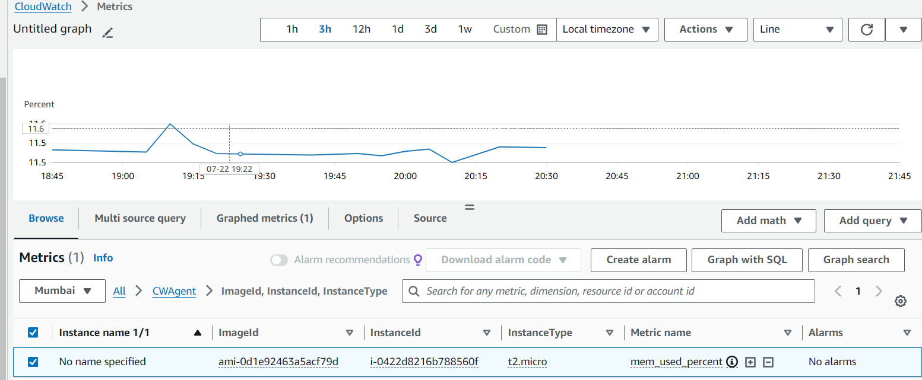

# References

* [Amazon CloudWatch Documentation](https://docs.aws.amazon.com/AmazonCloudWatch/latest/monitoring/install-CloudWatch-Agent.html)
* <https://www.youtube.com/watch?v=vX6OvYDWOZQ>

# 